Budgeting Basics!

FLA Meeting and Budgeting Workshop Recap
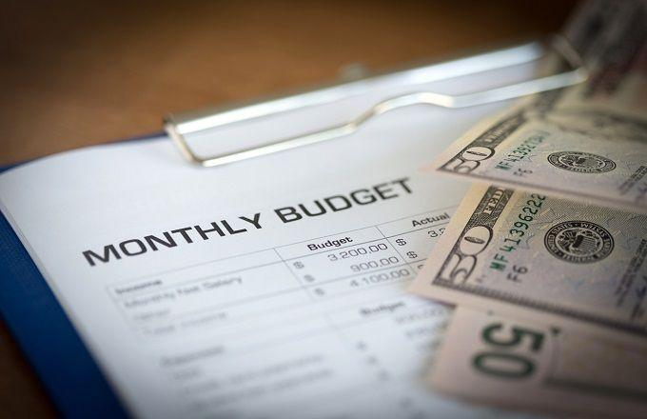
Recently, the Financial Literacy Association at UCI (FLA) had its inaugural meeting and workshop to kick off the 2018-2019 year for our members. If you didn’t make it out to the workshop, it was on the personal finance topic of budgeting and was taught by Angela Lim, a Financial Analyst at Amazon (the presentation can be found here). Angela covered a variety of reasons why budgeting is important and also provided the steps needed to start budgeting yourself!

Budgeting can be a useful tool to help you track what your money is being spent on, and a good way to do this is by breaking down your expenses into three different categories: essentials, savings/paying off debt, and lifestyle/entertainment expenses. Doing this will not only help you meet your financial goals, such as paying off your student loans, but also your personal goals, like saving up to purchase a new phone or computer.

Additional Resources

Although creating a budget may seem intimidating, there are plenty of premade budget templates that you can get for free, so don’t feel like you have to start from scratch. Excel has some good ones, or you can download a template online.

Another great free resource is an app called Mint, which makes budgeting super easy. You can link Mint to your financial accounts and it will walk you through the process of creating a budget. It even recommends an amount for each category based on your historical spending patterns. And when you’ve created the budget, Mint shows you how your actual spending each month compares to your budget. Click here to sign up for free.

If you’d like to learn more about budgeting, shoot us an email or check out some of the helpful links below:
- https://www.investopedia.com/financial-edge/1109/6-reasons-why-you-need-a-budget.aspx
- https://www.youtube.com/watch?v=lrJ1jr8mrVk
- https://www.nerdwallet.com/blog/finance/how-to-build-a-budget/

